**Thanks for choosing FPS Game Controller Template**

**Features :**

1. Fully customizable **First Person Shooting** mechanism.
2. 3 types of Enemy

* **Normal enemy**
* **Shooter enemy** (They will shoot Player from their fixed position while Player entered their Range)
* **AI Shooter enemy** (They will not only shoot Player, they will also follow Player if Player enter their Range. They will follow until kill the Player)

**How to Start ?**

* **Normal enemy :**

1. First create a new scene.
2. Create a plane or drag & drop the plane from **Prepab** folder into the scene.
3. Go to Inspector Window 🡪 Add a tag 🡪 name it **‘Player’**.

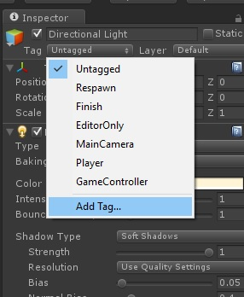

1. Drag your Player Character model into the scene or you can just create a Capsule for testing purpose. Rename it **‘Player’**
2. Select the Player 🡪 Change its tag to **‘Player’**

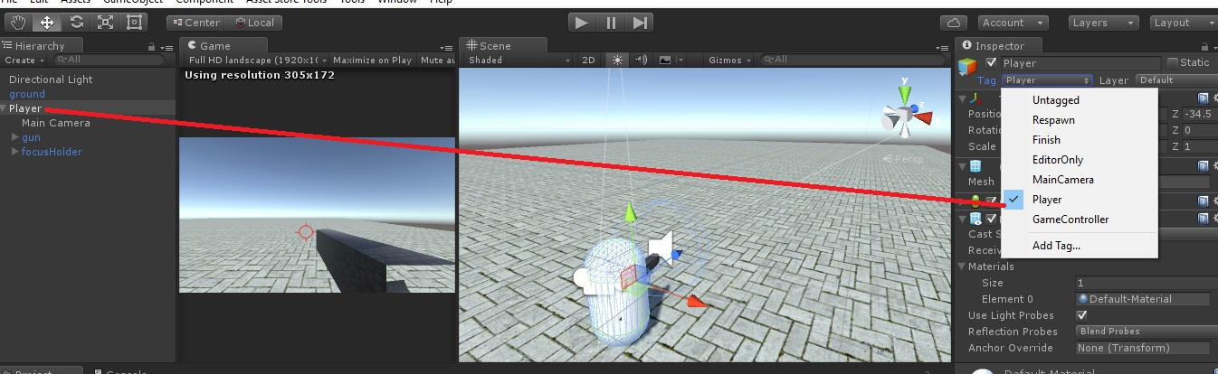

1. Make the **Main Camera** a child object of your **Player**.

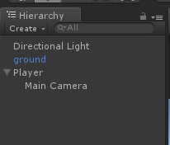

1. Drag & drop the **gun** into the scene(or your custom gun), place it in front of your **Player** as your wish, make the **gun** a child of your **Player**. You can see the sample scenes from the Scene folder.
2. Now drag & drop the **focusHolder** prepab into your scene, make it a child of your **Player**,place it in front your **gun**. This prepab contains with a cross target.
3. Now Select your **Player** 🡪 add **PlayerController.cs** script into it.

***W or Up Arrow 🡪 Move forward***

***S or Down Arrow 🡪 Move Backward***

***A or Left Arrow 🡪 Rotate Left***

***D or Right Arrow 🡪 Rotate Right***

***Mouse Left Key 🡪 Fire or Shoot***

1. **Now play your scene, you can shoot now if everything is ok.**
2. To add an enemy, just drag & drop the **SimpleEnemy** prepab into your scene.
3. Now shoot the enemy, you will see the enemy health is decreasing.

**Hurrah!** You have created the fundamental environment for FPS game.

1. For better understanding see the scene named ‘**1_SimpleEnemy’** from scene folder.

* **Shooter enemy :**

1. Do the same as like previous steps from **1-9** exactly.
2. Now Select your **Player** 🡪 add **PlayerController.cs** script into it 🡪 add **PlayerTakeDamage.cs** script 🡪 add a **Rigidbody**

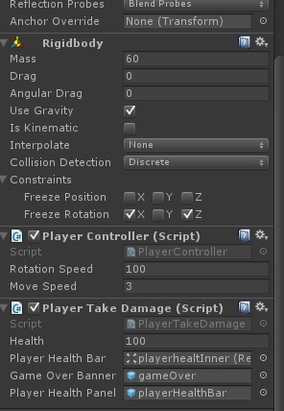

1. Drag & drop the **CanvasPlayer** prepab into your scene.
2. Select the **Player** 🡪 Show the gameobjects from **CanvasPlayer** to **PlayerTakeDamage.cs** script like below.

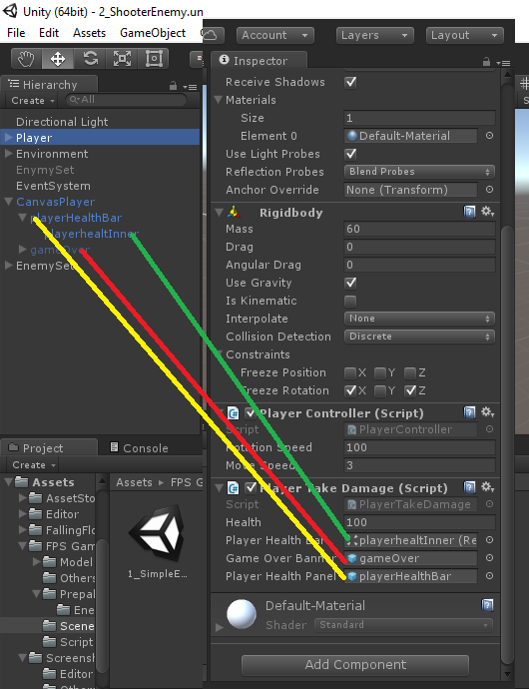

1. Now drag & drop **ShooterEnemy** prepab into your scene. Place it far distance from the player.
2. Now play your scene 🡪 go to the near of your enemy 🡪 if it starts to shoot you then everything is ok.

Note : It it’s not starting to shoot you than you are not bigger enough than the enemy, that’s why it can’t find you in its shooting range.

1. For better understand please see the example scene named **2_ShooterEnemy** in scene folder.

* **AI_Shooter enemy**

Same as Shooter enemy but its advanced feature is, it will start to follow you while you reach into its range. It will continuously follow & shoot you until your death or you kill it first.

**For more info contact with me:**

Email : turzoxpress@gmail.com